Model End Assignment Data Cleaning Analysing & Visualization
CUSTOMER DIM
STEP 1: Find and replace the value C- into CUST
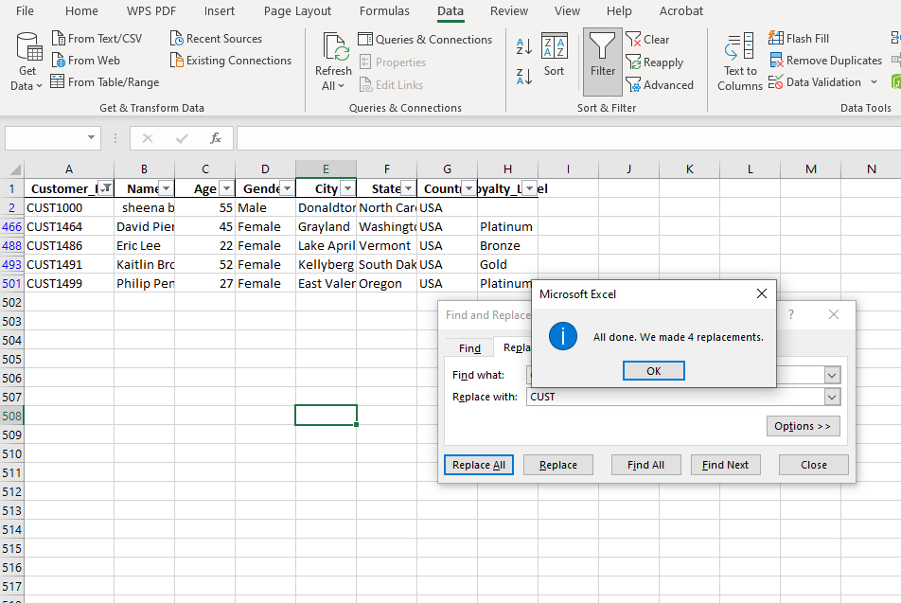
STEP 2 : USE PROPER, TRIM FUNCTION TO MODIFY THE NAME
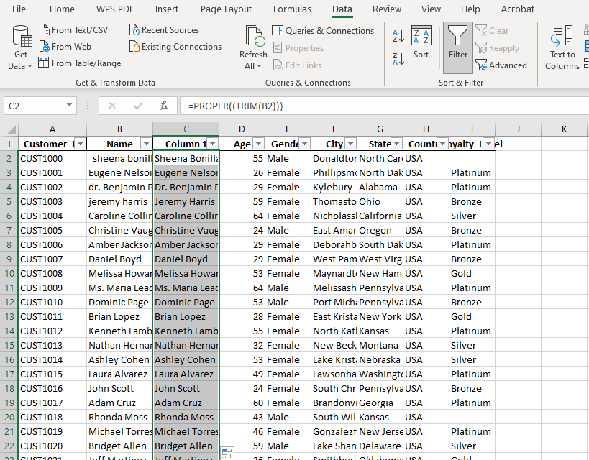
Step: 3 Find & replacing United states of America to USA.
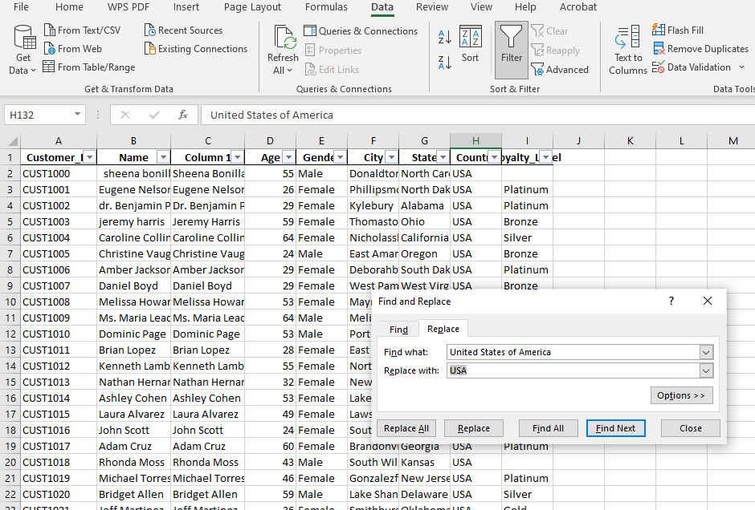

Step 4: Missing loyalty-level values – we see out of 500 only 4 customer data has no Loyalty value so removing 4 out of 500 data will not be affected. Therefore, removed the customer data which had no loyalty value.

PRODUCT DIM

Find and replace the value P- into PROD

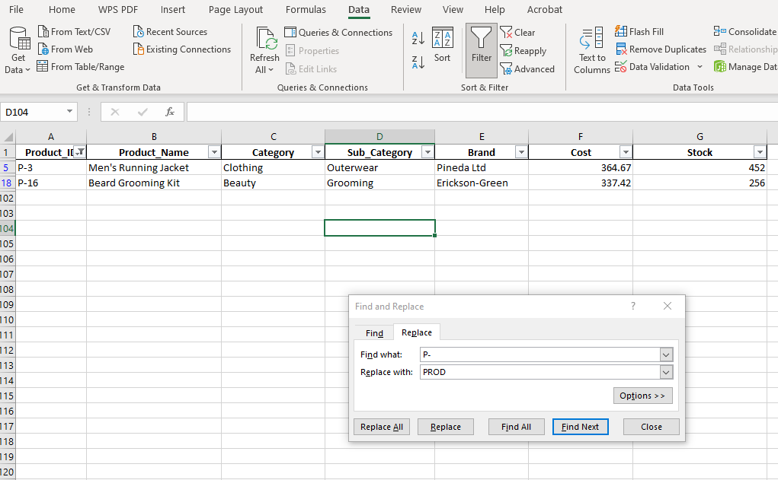
Missing Cost and Stock values; inconsistent product ID formatting
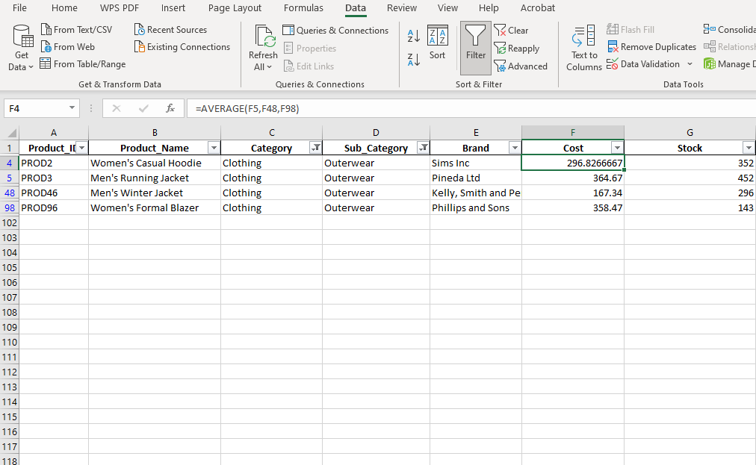
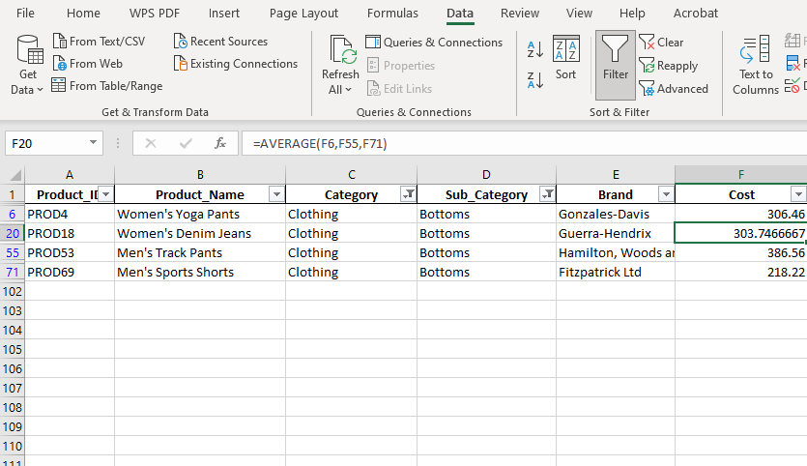

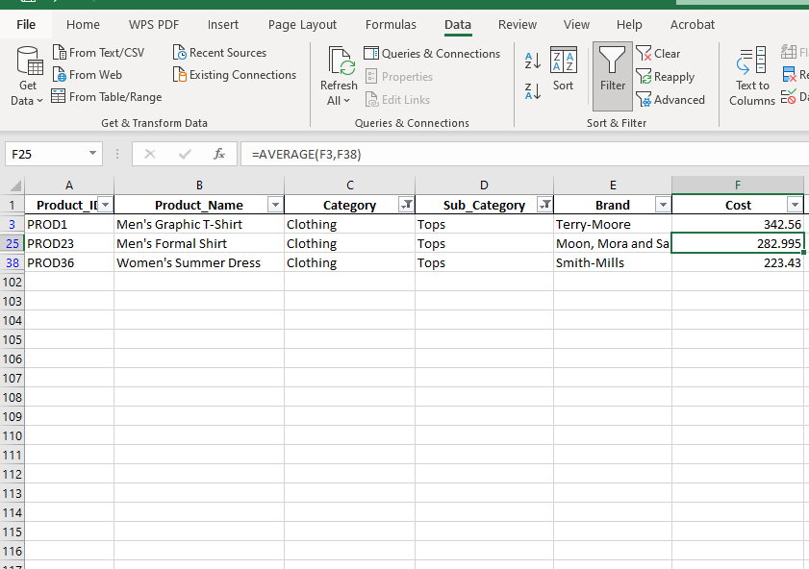

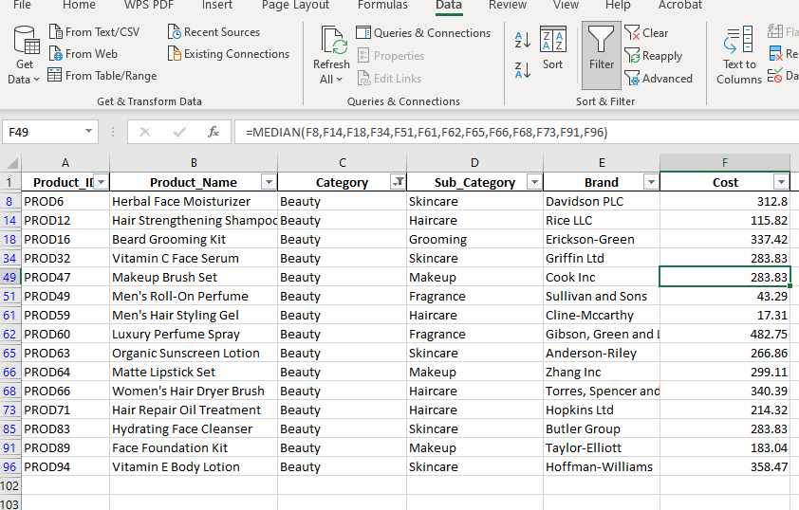
Finding missing stock values through Median
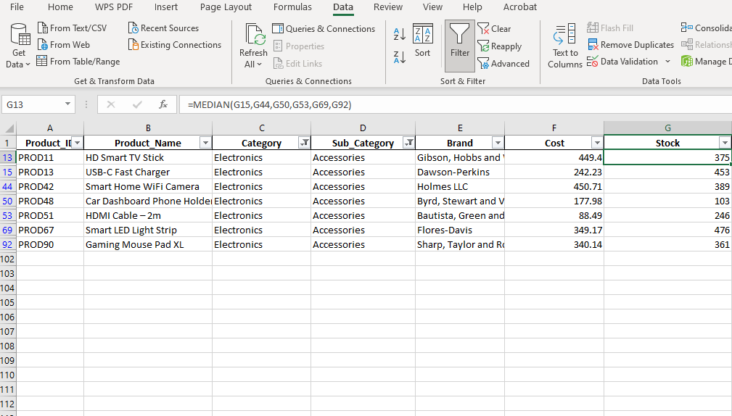

Round off the cost and stock values by using decrease decimal
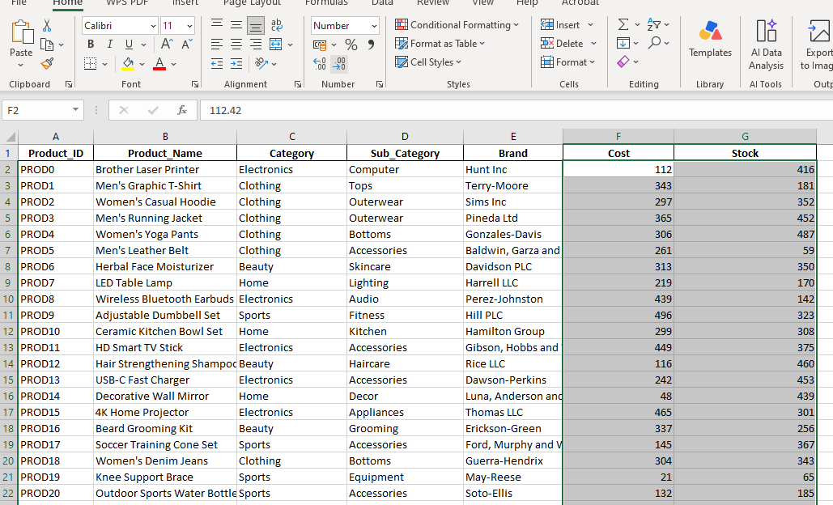

STORE DIM
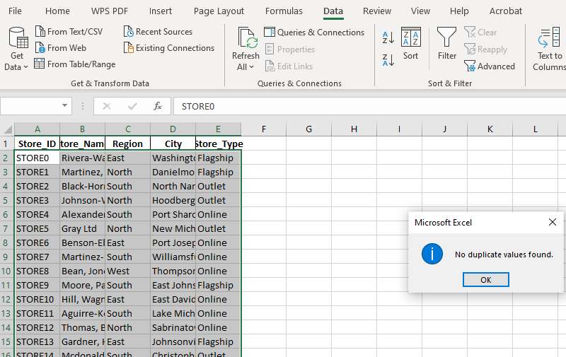

SALES FACT
Step 1: To identify the missing value in the Quantity used the below formula to calculate the Missing Value

Quantity = Total Amount / (Unit_Price*(1-Discount))

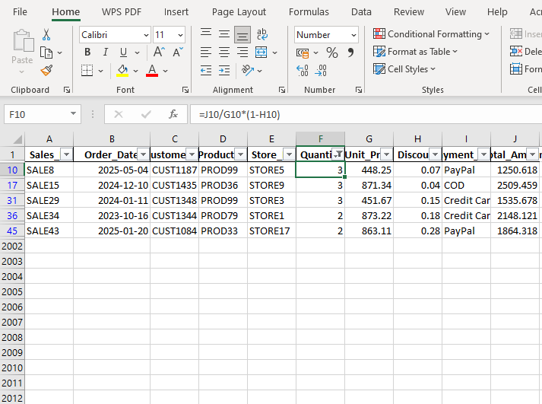

Step 2: To Identify the Missing Discount Values

Discount = 1-(Total Amount/(Quantity*Unit_Price))
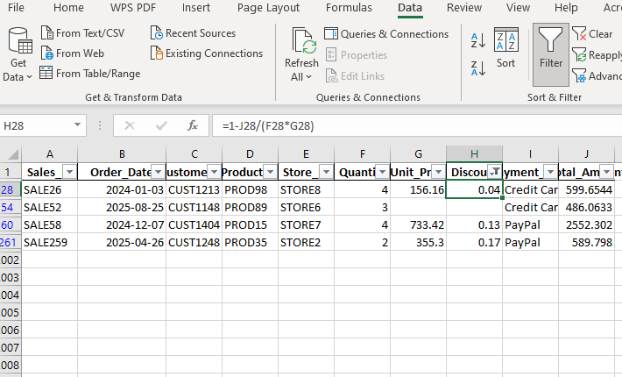

Step 3: To Identify the Missing Unit Price
Unit price = Total Amount /Quantity * (1-Discount)
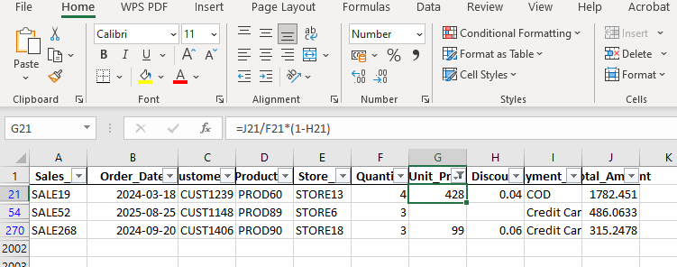
Step 4: To Identify the Missing Total Amount
Total amount = (Quantity*Unit_price)*(1-Discount)
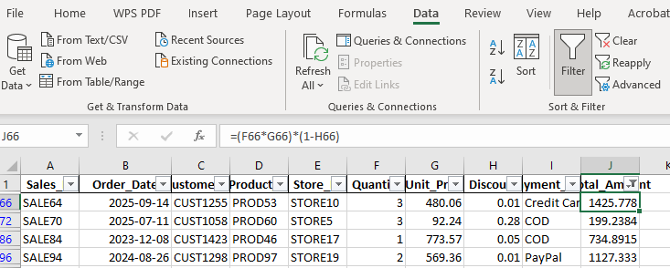

Descriptive statistic

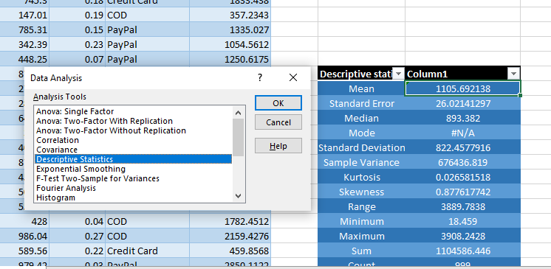

CREATED PIVOT TABLE

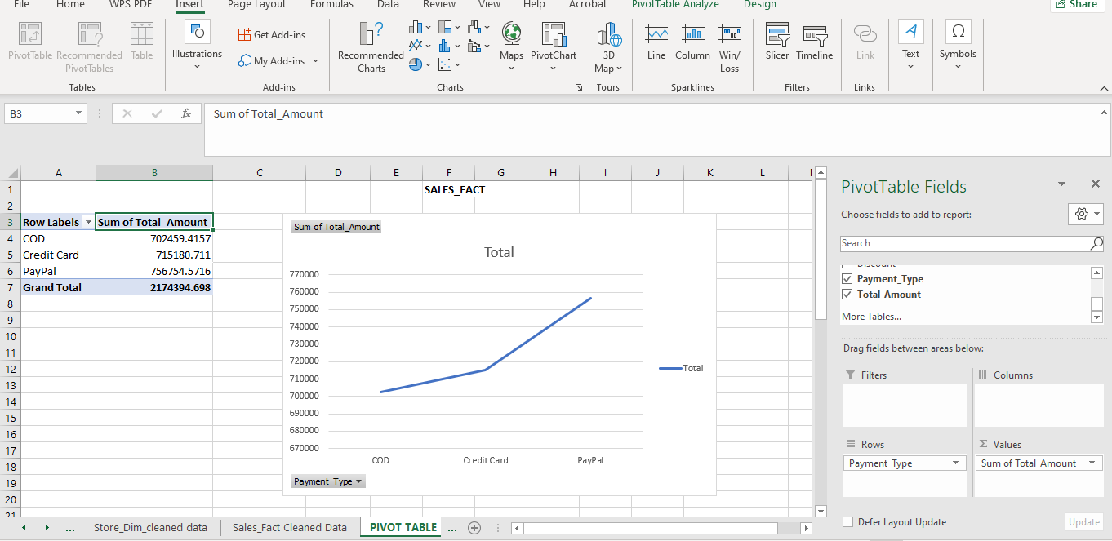

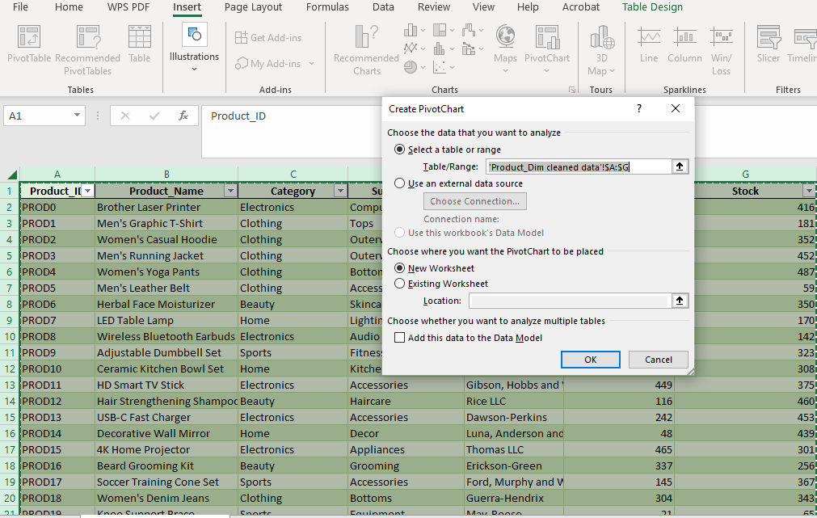
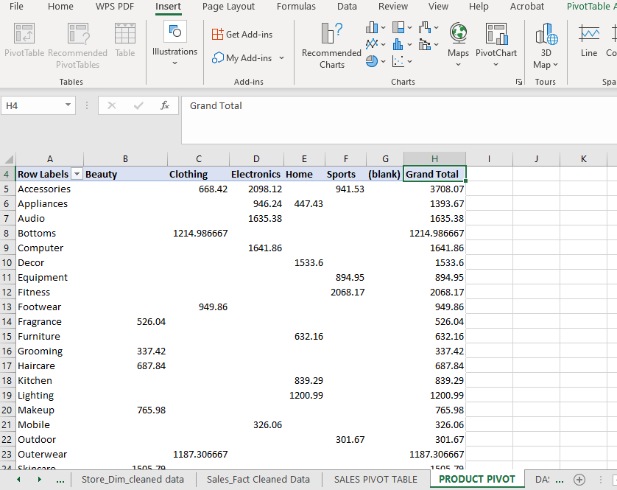

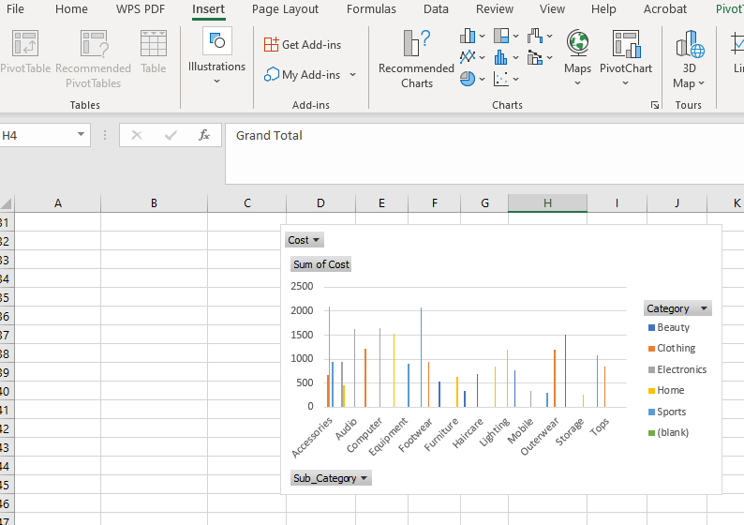

Created Relationship between tables
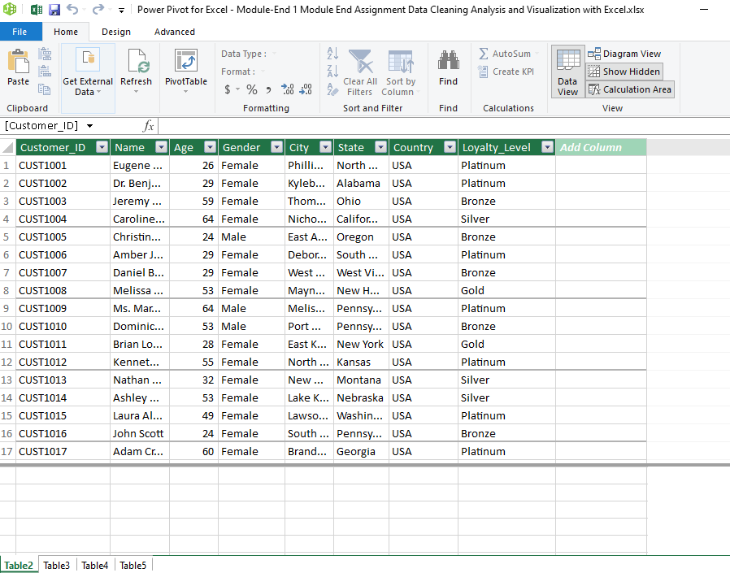
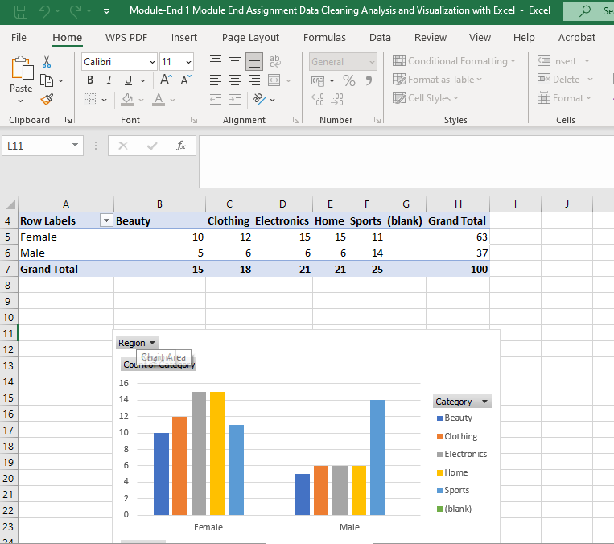

- Created a Sheet with all the Charts to form a dashboard
